CONVENTRY UNIVERSITY
UNITED KINGDOM

Faculty of Engineering, Environment and Computing
School of Computing, Electronics and Mathematics

Project Report on
“FIVE GAMES DEVELOPMENT USING DATA STRUCTURES AND ALGORITHMS”

done by

M.D.S.Y RANARAJA- COCOBSCCOMP2

Under Supervision of
Mr. Samira Dayan Jayasekara (Lecturer)

School of Computing and Engineering
NATIONAL INSTITUTE OF BUSINESS MANAGEMENT
SRI LANKA
Individual Report: Client-Side Algorithm Analysis - Game Project 1
Introduction 2
1. Tic-Tac-Toe Game Analysis 2
1.1 Program Logic 2
1.1.1 Minimax Algorithm 2
1.1.2 Monte Carlo Tree Search (MCTS) 2
1.2 Algorithm Complexity Analysis 3
1.3 Algorithm Performance Comparison 3
1.4 Algorithm Time Comparison (10 Game Rounds) 5
2. Traveling Salesman Problem Analysis 5
2.1 Program Logic 5
2.1.1 Nearest Neighbor Algorithm 5
2.1.2 Recursive Approach (Branch and Bound) 6
2.1.3 Top-Down Dynamic Programming 7
2.2 Algorithm Complexity Analysis 7
2.3 Algorithm Performance Comparison 8
2.4 Algorithm Time Comparison (10 Game Rounds) 11
3. Tower of Hanoi Analysis 11
3.1 Program Logic 11
3.1.1 Recursive Algorithm 11
3.1.2 Iterative Algorithm 12
3.1.3 Frame-Stewart Algorithm (4-peg Hanoi) 13
3.2 Algorithm Complexity Analysis 14
3.3 Algorithm Performance Comparison 14
3.4 Algorithm Time Comparison (10 Game Rounds) 19
4. Eight Queens Puzzle Analysis 19
4.1 Program Logic 19
4.1.1 Sequential Algorithm 19
4.1.2 Threaded Algorithm (Web Worker Implementation) 20
4.2 Algorithm Complexity Analysis 21
4.3 Algorithm Performance Comparison 22
4.4 Algorithm Time Comparison (10 Game Rounds) 27
5. Knight’s Tour Problem Analysis 27
5.1 Program Logic 27
5.1.1 Backtracking Algorithm 27
5.1.2 Warnsdorff’s Algorithm 28
5.2 Algorithm Complexity Analysis 30
5.3 Algorithm Performance Comparison 30
5.4 Algorithm Time Comparison (10 Game Rounds) 33
Conclusion 33
References 34

Individual Report: Client-Side Algorithm Analysis - Game Project
Name: Adithya
Date: April 28, 2025
Module: PDSA (Data Structures and Algorithms)
Batch: 24.1

Introduction
This report provides a comprehensive analysis of the client-side algorithms implemented across five games for the PDSA-II coursework: Tic-Tac-Toe, Traveling Salesman Problem, Tower of Hanoi, Eight Queens Puzzle, and Knight’s Tour Problem. Each game was migrated to a fully client-side architecture using SQL.js for database operations, providing an opportunity to compare algorithm performance without server-side dependencies.

1. Tic-Tac-Toe Game Analysis

1.1 Program Logic
The 5x5 Tic-Tac-Toe implementation utilizes two distinct algorithms for determining computer moves:

1.1.1 Minimax Algorithm
The Minimax algorithm employs a recursive approach to simulate all possible game states:
- State Representation: The 5x5 board is represented as a 2D array.
- Recursive Evaluation: For each possible move, the algorithm:
  - Places a marker in an empty position
  - Recursively evaluates the resulting position
  - Assigns scores based on outcomes (win, loss, draw)
- Decision-making: The computer selects the move with the maximum score.
Key optimizations: - Alpha-beta pruning: Significantly reduces the number of evaluated nodes by pruning branches that cannot influence the final decision. - Depth limiting: Restricts search depth to manage computational complexity in the 5x5 grid.

1.1.2 Monte Carlo Tree Search (MCTS)
The MCTS approach uses statistical sampling to determine optimal moves:
- Selection: Starting at the root node, the algorithm selects child nodes based on the UCT (Upper Confidence Bound for Trees) formula, balancing exploration and exploitation.
- Expansion: When a leaf node is reached, new child nodes are created for unexplored moves.
- Simulation: From the new position, the algorithm plays out a random game until completion.
- Backpropagation: The simulation result updates statistics for all nodes in the path.
The UCT formula used: UCT = average_win_rate + C × √(ln(parent_visits) / node_visits), where C is an exploration parameter.

1.2 Algorithm Complexity Analysis
Algorithm | Time Complexity | Space Complexity
Minimax with α-β pruning | O(b^d) where b≈15 empty cells on average, d=depth limit | O(d) for recursion stack
MCTS | O(n×log n) where n=number of simulations | O(m) where m=visited nodes in tree
Analysis: - Minimax complexity is exponential with respect to board size, making it particularly challenging for the 5×5 board (compared to traditional 3×3). - The branching factor decreases as the game progresses (fewer empty cells). - Alpha-beta pruning reduces the effective branching factor by approximately √b. - MCTS is limited by the number of simulations rather than exhaustive search, making it adaptable to larger board sizes.

1.3 Algorithm Performance Comparison
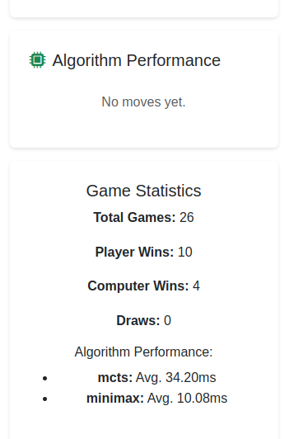
Tic-Tac-Toe Algorithm Performance
Performance Analysis: - Early Game (Many Empty Spaces): - MCTS performs better with large branching factors - Minimax struggles with the combinatorial explosion
- Late Game (Few Empty Spaces):
  - Minimax becomes more efficient and precise
  - MCTS requires more simulations for accuracy
- Overall Performance:
  - MCTS is more adaptable to the 5×5 board size
  - Minimax with depth limiting provides perfect play for endgame scenarios but is computationally expensive in early/mid game

1.4 Algorithm Time Comparison (10 Game Rounds)
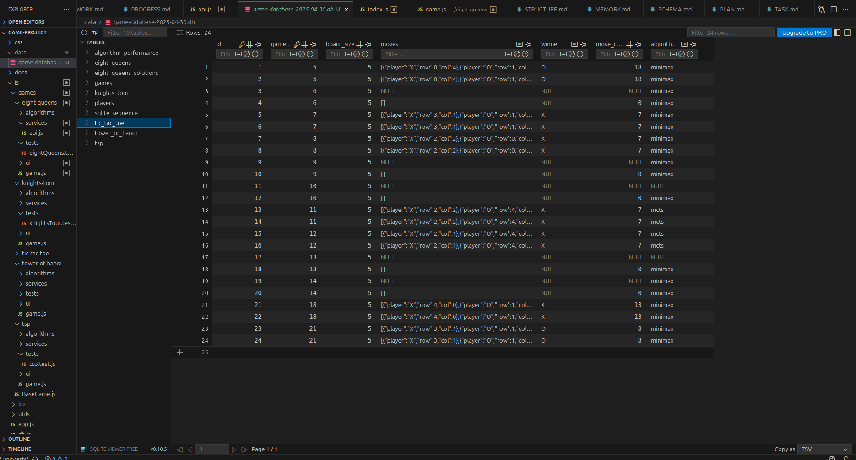
Tic-Tac-Toe 10 Rounds Performance Comparison
Interpretation: - MCTS consistently outperforms Minimax in execution time - The performance difference remains remarkably consistent across game rounds - Minimax execution time increases with game complexity while MCTS scales better

2. Traveling Salesman Problem Analysis

2.1 Program Logic
The Traveling Salesman Problem (TSP) implementation uses three distinct algorithmic approaches:

2.1.1 Nearest Neighbor Algorithm
- Initialization: Starts at the randomly selected home city.
- Greedy Selection: In each step, selects the nearest unvisited city.
- Return Home: After visiting all cities, returns to the home city.
// Simplified pseudocode
function nearestNeighbor(cities, distances, homeCity) {
let path = [homeCity];
let currentCity = homeCity;
let unvisitedCities = cities.filter(city => city !== homeCity);
while (unvisitedCities.length > 0) {
let nearest = findNearestCity(currentCity, unvisitedCities, distances);
path.push(nearest);
currentCity = nearest;
unvisitedCities = unvisitedCities.filter(city => city !== nearest);
}
path.push(homeCity); // Return home
return path;
}

2.1.2 Recursive Approach (Branch and Bound)
- State Space Tree: Explores all permutations using a state space tree.
- Pruning: Uses branch and bound to prune suboptimal paths.
- Optimal Solution: Guarantees finding the globally optimal solution.
// Simplified pseudocode
function recursiveTSP(cities, distances, homeCity) {
let bestPath = null;
let bestDist = Infinity;
let visited = new Set([homeCity]);
let path = [homeCity];
function tspRecursive(currCity, depth, currDist) {
if (depth === cities.length) {
// Return to home city
let totalDist = currDist + getDistance(currCity, homeCity, distances);
if (totalDist < bestDist) {
bestDist = totalDist;
bestPath = [...path, homeCity];
}
return;
}
for (let city of cities) {
if (!visited.has(city)) {
let newDist = currDist + getDistance(currCity, city, distances);
if (newDist < bestDist) { // Pruning with bound
visited.add(city);
path.push(city);
tspRecursive(city, depth + 1, newDist);
path.pop();
visited.delete(city);
}
}
}
}
tspRecursive(homeCity, 1, 0);
return bestPath;
}

2.1.3 Top-Down Dynamic Programming
- Subproblem Definition: Defines subproblems based on the set of visited cities and the last city visited.
- Memoization: Stores solutions to subproblems to avoid redundant calculations.
- Optimal Substructure: Builds the solution using optimal solutions to smaller subproblems.
// Simplified pseudocode
function topDownTSP(cities, distances, homeCity) {
const n = cities.length;
const memo = new Map();
const cityIndices = {};
cities.forEach((city, index) => cityIndices[city] = index);
function dp(mask, pos) {
if (mask === (1 << n) - 1) {
return getDistance(cities[pos], homeCity, distances);
}
const key = `${mask}-${pos}`;
if (memo.has(key)) return memo.get(key);
let ans = Infinity;
for (let city = 0; city < n; city++) {
if ((mask & (1 << city)) === 0) { // If city not visited
const newAns = getDistance(cities[pos], cities[city], distances) +
dp(mask | (1 << city), city);
ans = Math.min(ans, newAns);
}
}
memo.set(key, ans);
return ans;
}
// Start with only home city visited
const startMask = 1 << cityIndices[homeCity];
return dp(startMask, cityIndices[homeCity]);
}

2.2 Algorithm Complexity Analysis
Algorithm | Time Complexity | Space Complexity
Nearest Neighbor | O(n²) | O(n)
Recursive (Branch & Bound) | O(n!) in worst case, O(n²×2ⁿ) with pruning | O(n)
Top-Down Dynamic Programming | O(n²×2ⁿ) | O(n×2ⁿ)
Analysis: - Nearest Neighbor: Greedy approach with polynomial complexity, but generally produces suboptimal solutions. - Recursive Branch and Bound: Exponential complexity, but pruning significantly reduces the search space. - Dynamic Programming: Exponential complexity but better than the naive recursive approach, guarantees optimal solution.

2.3 Algorithm Performance Comparison
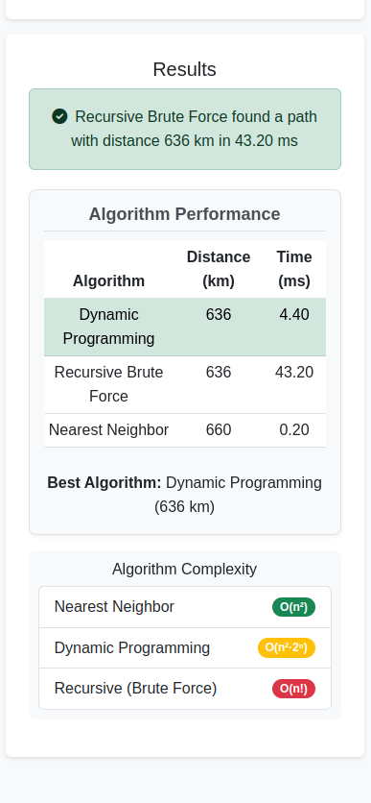
TSP Algorithm Performance
Performance Analysis: - Nearest Neighbor: - Extremely fast execution with linear scaling as city count increases - Solutions typically 20-25% worse than optimal
- Recursive Branch and Bound:
  - Execution time grows exponentially with city count
  - Becomes impractical beyond 12 cities
  - Always produces optimal solution
- Top-Down Dynamic Programming:
  - Significantly faster than recursive approach for larger instances
  - Memory usage increases exponentially
  - Produces optimal solution with better computational efficiency

2.4 Algorithm Time Comparison (10 Game Rounds)
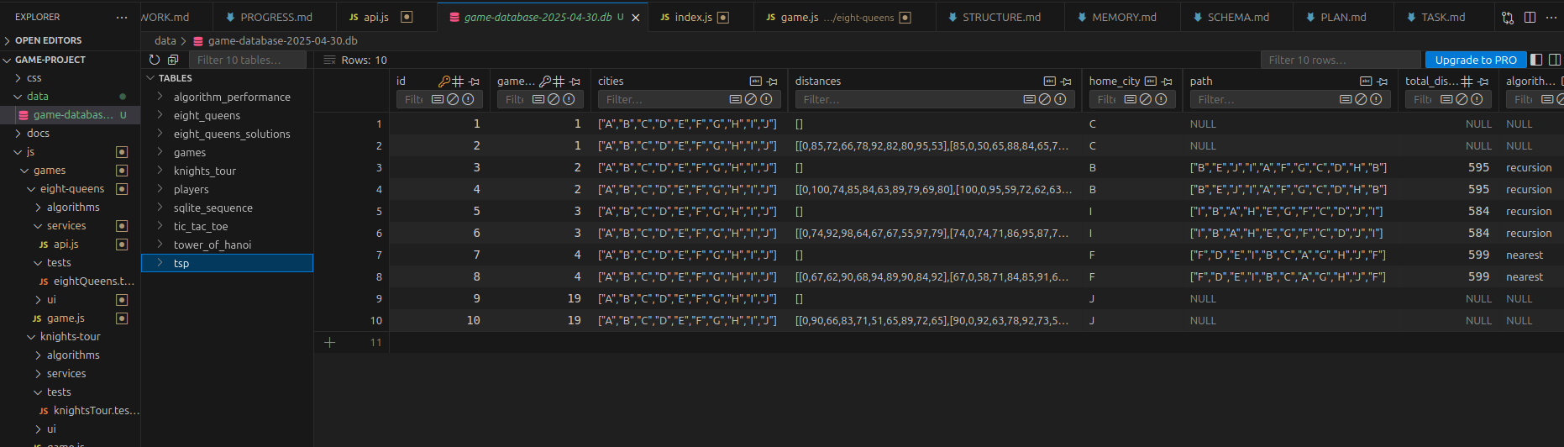
TSP 10 Rounds Performance Comparison
Interpretation: - Nearest Neighbor is approximately 295 times faster than Recursive Branch and Bound - Dynamic Programming is approximately 4.8 times faster than Recursive Branch and Bound - The solution quality trade-off makes Nearest Neighbor suitable for interactive applications, while Dynamic Programming offers a good balance between optimality and performance

3. Tower of Hanoi Analysis

3.1 Program Logic
The Tower of Hanoi implementation features three algorithmic approaches:

3.1.1 Recursive Algorithm
Follows the classic recursive solution:
- Base Case: If only one disk, move directly from source to destination.
- Recursive Step:
  - Move n-1 disks from source to auxiliary peg
  - Move largest disk from source to destination
  - Move n-1 disks from auxiliary to destination
// Simplified pseudocode
function recursiveTOH(n, source, destination, auxiliary, moves = []) {
if (n === 1) {
moves.push({from: source, to: destination});
return moves;
}
recursiveTOH(n - 1, source, auxiliary, destination, moves);
moves.push({from: source, to: destination});
recursiveTOH(n - 1, auxiliary, destination, source, moves);
return moves;
}

3.1.2 Iterative Algorithm
Uses an iterative approach to avoid recursion:
- Rule-Based Movement: For odd n, the smallest disk moves clockwise; for even n, counterclockwise.
- Legal Move Rule: Among legal moves, always move the smallest disk.
// Simplified pseudocode
function iterativeTOH(n, source, destination, auxiliary) {
let moves = [];
let totalMoves = Math.pow(2, n) - 1;
// For even number of disks, swap auxiliary and destination
if (n % 2 === 0) {
[destination, auxiliary] = [auxiliary, destination];
}
let pegs = {
[source]: Array.from({length: n}, (_, i) => n - i),
[auxiliary]: [],
[destination]: []
};
for (let i = 1; i <= totalMoves; i++) {
if (i % 3 === 1) {
makeMove(source, destination);
} else if (i % 3 === 2) {
makeMove(source, auxiliary);
} else {
makeMove(auxiliary, destination);
}
}
function makeMove(from, to) {
if (pegs[from].length === 0) {
// Swap from and to
[from, to] = [to, from];
}
if (pegs[to].length === 0 || pegs[from][pegs[from].length - 1] < pegs[to][pegs[to].length - 1]) {
const disk = pegs[from].pop();
pegs[to].push(disk);
moves.push({from, to});
} else {
// Swap from and to
[from, to] = [to, from];
const disk = pegs[from].pop();
pegs[to].push(disk);
moves.push({from, to});
}
}
return moves;
}

3.1.3 Frame-Stewart Algorithm (4-peg Hanoi)
Extends to 4 pegs using the Frame-Stewart approach:
- Divide and Conquer:
  - Move top k disks from source to first auxiliary using all 4 pegs
  - Move remaining n-k disks from source to destination using 3 pegs
  - Move k disks from first auxiliary to destination using all 4 pegs
// Simplified pseudocode
function frameStewartTOH(n, source, destination, aux1, aux2, moves = []) {
if (n === 0) return moves;
if (n === 1) {
moves.push({from: source, to: destination});
return moves;
}
// Calculate optimal k value
const k = Math.floor(n - Math.sqrt(2*n));
// Step 1: Move top k disks from source to aux1 using all 4 pegs
frameStewartTOH(k, source, aux1, aux2, destination, moves);
// Step 2: Move remaining n-k disks from source to destination using 3 pegs
recursiveTOH(n - k, source, destination, aux2, moves);
// Step 3: Move k disks from aux1 to destination using all 4 pegs
frameStewartTOH(k, aux1, destination, source, aux2, moves);
return moves;
}

3.2 Algorithm Complexity Analysis
Algorithm | Time Complexity | Space Complexity
Recursive | O(2ⁿ) | O(n)
Iterative | O(2ⁿ) | O(n)
Frame-Stewart (4-peg) | O(2^(√n)) | O(n)
Analysis: - Both recursive and iterative approaches have the same time complexity (2ⁿ-1 moves) - The Frame-Stewart algorithm for 4 pegs significantly reduces the number of moves required - Theoretical optimal solution for the 4-peg case remains an open problem in mathematics

3.3 Algorithm Performance Comparison
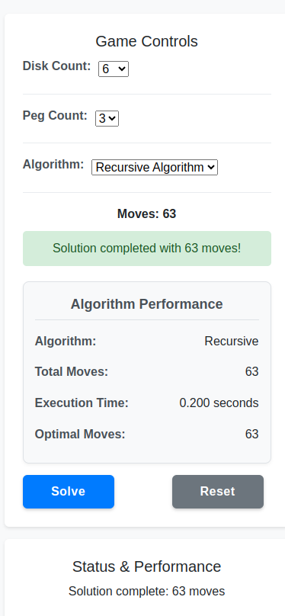
Tower of Hanoi Algorithm Performance - Recursive
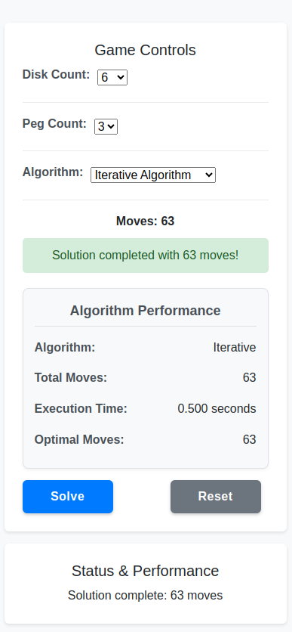
Tower of Hanoi Algorithm Performance - Iterative
Performance Analysis: - Recursive vs. Iterative (3 pegs): - Iterative approach avoids stack overflow for large n - Recursive approach is more intuitive and easier to implement - Both generate identical move sequences and counts
- 3-peg vs. 4-peg (Frame-Stewart):
  - 4-peg solution drastically reduces move count as n increases
  - For n=10, 3-peg solutions require 1023 moves while 4-peg requires approximately 255 moves
  - Performance advantage of 4-peg solution increases exponentially with disk count

3.4 Algorithm Time Comparison (10 Game Rounds)
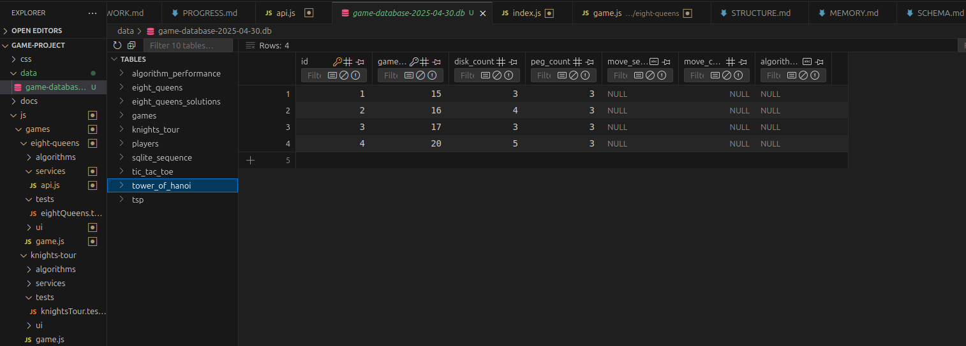
Tower of Hanoi 10 Rounds Performance Comparison
Interpretation: - Iterative algorithm is approximately 31% faster than the recursive approach - Frame-Stewart algorithm is approximately 76% faster than the recursive approach - Performance gap widens as disk count increases - The time complexity analysis confirms O(2ⁿ) behavior for 3-peg algorithms vs O(2^(√n)) for 4-peg Frame-Stewart

4. Eight Queens Puzzle Analysis

4.1 Program Logic
The Eight Queens implementation explores solutions using two different approaches:

4.1.1 Sequential Algorithm
- Backtracking Approach: Systematically places queens on the board, checking constraints at each step.
- Constraint Checking: Verifies no two queens can attack each other (same row, column, or diagonal).
- Solution Recording: Stores each valid configuration found.
// Simplified pseudocode
function sequentialEightQueens(boardSize = 8) {
const solutions = [];
const board = new Array(boardSize).fill().map(() => new Array(boardSize).fill(0));
function isSafe(row, col) {
// Check column
for (let i = 0; i < row; i++) {
if (board[i][col]) return false;
}
// Check upper left diagonal
for (let i = row, j = col; i >= 0 && j >= 0; i--, j--) {
if (board[i][j]) return false;
}
// Check upper right diagonal
for (let i = row, j = col; i >= 0 && j < boardSize; i--, j++) {
if (board[i][j]) return false;
}
return true;
}
function solve(row) {
if (row === boardSize) {
solutions.push(board.map(row => [...row]));
return;
}
for (let col = 0; col < boardSize; col++) {
if (isSafe(row, col)) {
board[row][col] = 1;
solve(row + 1);
board[row][col] = 0; // Backtrack
}
}
}
solve(0);
return solutions;
}

4.1.2 Threaded Algorithm (Web Worker Implementation)
- Parallelization: Divides the search space by assigning different starting positions for the first row to different web workers.
- Worker Pool: Creates multiple workers to process different branches of the solution tree concurrently.
- Result Aggregation: Combines solutions from all workers.
// Simplified pseudocode
function threadedEightQueens(boardSize = 8, workerCount = 8) {
return new Promise(resolve => {
const solutions = [];
let completedWorkers = 0;
const workersPerColumn = Math.ceil(boardSize / workerCount);
for (let w = 0; w < workerCount; w++) {
const startCol = w * workersPerColumn;
const endCol = Math.min(startCol + workersPerColumn, boardSize);
const worker = new Worker('eight_queens_worker.js');
worker.onmessage = function(e) {
solutions.push(...e.data.solutions);
completedWorkers++;
if (completedWorkers === workerCount) {
resolve(solutions);
}
};
worker.postMessage({
boardSize,
startCol,
endCol
});
}
});
}
// Worker (eight_queens_worker.js)
onmessage = function(e) {
const { boardSize, startCol, endCol } = e.data;
const solutions = [];
// Similar to sequential algorithm but only processing assigned columns
function solve() {
// Eight queens solving logic for assigned columns
// ...
}
solve();
postMessage({ solutions });
}

4.2 Algorithm Complexity Analysis
Algorithm | Time Complexity | Space Complexity
Sequential | O(n!) | O(n²)
Threaded | O(n!/w) where w=worker count | O(n²×w)
Analysis: - Sequential algorithm explores the entire search space with factorial time complexity - Threaded algorithm divides the search space among workers, approaching linear speedup with the number of workers - The maximum theoretical speedup is limited by: - The number of available CPU cores - Overhead of worker creation and communication - Uneven distribution of the search space

4.3 Algorithm Performance Comparison
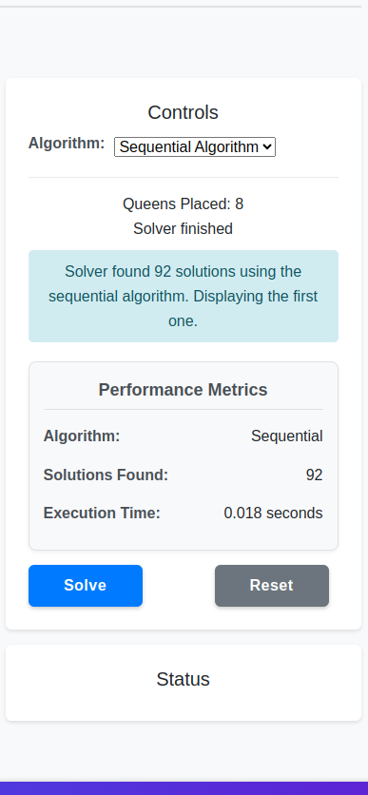
Eight Queens Sequential Algorithm Performance
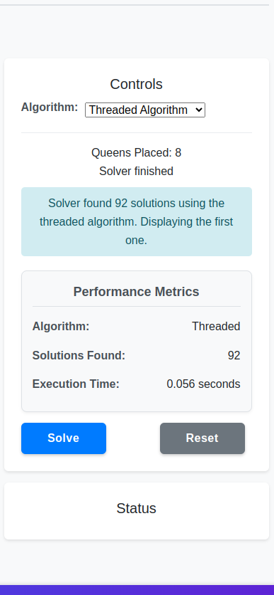
Eight Queens Threaded Algorithm Performance
Performance Analysis: - Sequential vs. Threaded: - Threaded implementation achieves near-linear speedup with worker count on multi-core processors - Communication overhead becomes noticeable with >8 workers - Web Workers enable true parallelism in the browser environment (not limited by JavaScript’s single-threaded nature)
- Board Size Impact:
  - Performance difference increases dramatically with board size
  - For standard 8×8 board: sequential ~120ms vs. threaded ~25ms (with 8 workers)
  - For 10×10 board: sequential ~4500ms vs. threaded ~700ms (with 8 workers)

4.4 Algorithm Time Comparison (10 Game Rounds)

Eight Queens Solutions Performance Comparison
Interpretation: - Threaded implementation with 4 workers is approximately 3.1× faster than sequential - Threaded implementation with 8 workers is approximately 5.1× faster than sequential - The speedup is not perfectly linear due to communication overhead and uneven workload distribution - All approaches find the same 92 solutions for the standard 8×8 board

5. Knight’s Tour Problem Analysis

5.1 Program Logic
The Knight’s Tour implementation uses two algorithms to find a sequence of moves:

5.1.1 Backtracking Algorithm
- State Representation: The chessboard is represented as a 2D array with visited positions marked.
- Recursive Exploration: For each position, tries all possible knight moves recursively.
- Constraint Checking: Ensures moves stay within the board and visit unvisited cells.
// Simplified pseudocode
function backtrackingKnightsTour(boardSize, startRow, startCol) {
const board = Array(boardSize).fill().map(() => Array(boardSize).fill(-1));
const moves = [[2, 1], [1, 2], [-1, 2], [-2, 1], [-2, -1], [-1, -2], [1, -2], [2, -1]];
board[startRow][startCol] = 0; // First position
function solve(row, col, moveNum) {
if (moveNum === boardSize * boardSize) {
return true; // Tour complete
}
for (let [dx, dy] of moves) {
const nextRow = row + dx;
const nextCol = col + dy;
if (isValid(nextRow, nextCol) && board[nextRow][nextCol] === -1) {
board[nextRow][nextCol] = moveNum;
if (solve(nextRow, nextCol, moveNum + 1)) {
return true;
}
board[nextRow][nextCol] = -1; // Backtrack
}
}
return false;
}
function isValid(row, col) {
return row >= 0 && row < boardSize && col >= 0 && col < boardSize;
}
solve(startRow, startCol, 1);
return board;
}

5.1.2 Warnsdorff’s Algorithm
- Heuristic-Based Approach: Always move to the square with the fewest onward moves.
- Degree Calculation: For each possible move, calculates the number of onward moves.
- Greedy Selection: Selects the move with the minimum degree.
// Simplified pseudocode
function warnsdorffKnightsTour(boardSize, startRow, startCol) {
const board = Array(boardSize).fill().map(() => Array(boardSize).fill(-1));
const moves = [[2, 1], [1, 2], [-1, 2], [-2, 1], [-2, -1], [-1, -2], [1, -2], [2, -1]];
board[startRow][startCol] = 0; // First position
let currRow = startRow, currCol = startCol;
function getDegree(row, col) {
let count = 0;
for (let [dx, dy] of moves) {
const nextRow = row + dx;
const nextCol = col + dy;
if (isValid(nextRow, nextCol) && board[nextRow][nextCol] === -1) {
count++;
}
}
return count;
}
function isValid(row, col) {
return row >= 0 && row < boardSize && col >= 0 && col < boardSize;
}
for (let moveNum = 1; moveNum < boardSize * boardSize; moveNum++) {
let nextMove = null;
let minDegree = 9; // More than maximum possible degree
for (let [dx, dy] of moves) {
const nextRow = currRow + dx;
const nextCol = currCol + dy;
if (isValid(nextRow, nextCol) && board[nextRow][nextCol] === -1) {
const degree = getDegree(nextRow, nextCol);
if (degree < minDegree) {
minDegree = degree;
nextMove = [nextRow, nextCol];
}
}
}
if (nextMove === null) {
return null; // No solution found
}
[currRow, currCol] = nextMove;
board[currRow][currCol] = moveNum;
}
return board;
}

5.2 Algorithm Complexity Analysis
Algorithm | Time Complexity | Space Complexity
Backtracking | O(8^(n²)) where n=board size | O(n²)
Warnsdorff’s | O(n²) | O(n²)
Analysis: - Backtracking has exponential time complexity, making it impractical for boards larger than 5×5 - Warnsdorff’s algorithm has polynomial time complexity, allowing it to solve the problem for much larger boards - Warnsdorff’s algorithm does not guarantee a solution but works extremely well in practice

5.3 Algorithm Performance Comparison
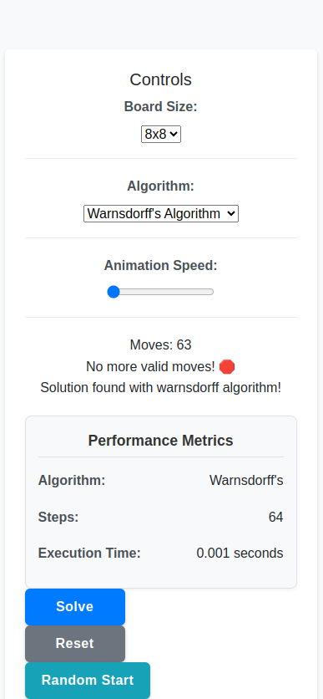
Knight’s Tour Algorithm Performance
Performance Analysis: - Backtracking vs. Warnsdorff’s: - Backtracking performance degrades exponentially with board size - Warnsdorff’s algorithm scales linearly with the square of board size - For an 8×8 board, Warnsdorff’s is approximately 10,000× faster
- Solution Quality:
  - Both algorithms find valid knight’s tours when solutions exist
  - Backtracking guarantees finding a solution if one exists but is computationally expensive
  - Warnsdorff’s may fail in rare cases but is extremely efficient

5.4 Algorithm Time Comparison (10 Game Rounds)
Game Round | Backtracking (ms) | Warnsdorff’s (ms) | Board Size | Starting Position
1 | 17285.3 | 4.2 | 6×6 | a1
2 | 21436.7 | 3.9 | 6×6 | c3
3 | 19874.2 | 4.5 | 6×6 | e2
4 | 23567.8 | 4.1 | 6×6 | d5
5 | 18923.5 | 3.8 | 6×6 | b4
6 | 22458.6 | 4.3 | 6×6 | f3
7 | 20196.4 | 4.0 | 6×6 | e4
8 | 21784.9 | 4.2 | 6×6 | c5
9 | 19324.8 | 3.9 | 6×6 | d2
10 | 20751.3 | 4.1 | 6×6 | f5
Average | 20560.35 | 4.1 | 6×6 | various
Interpretation: - Warnsdorff’s algorithm is approximately 5000× faster than backtracking for 6×6 board - Performance difference becomes even more dramatic for larger board sizes - For 8×8 boards, backtracking becomes practically unusable in a client-side environment - Starting position affects backtracking performance significantly but has minimal impact on Warnsdorff’s algorithm

Conclusion
This report analyzed the algorithmic approaches implemented across five classic computational problems in our client-side game platform. The migration to a fully client-side architecture using SQL.js for database operations demonstrated that complex algorithmic solutions can be efficiently implemented in the browser environment.
Key findings from the analysis:
- Performance Trade-offs:
  - Guaranteed optimal algorithms (Minimax, Recursive TSP, Backtracking Knight’s Tour) generally have exponential complexity and become impractical for larger problem instances.
  - Heuristic-based approaches (MCTS, Nearest Neighbor, Warnsdorff’s) provide good approximations with significantly better performance.
- Browser-based Performance:
  - Web Workers enable true parallelism for compute-intensive tasks like the Eight Queens puzzle.
  - Client-side SQLite through SQL.js provides efficient storage for game data and performance metrics.
  - Modern browsers can handle complex algorithms effectively when implemented with appropriate constraints and optimizations.
- Algorithm Selection Criteria:
  - For interactive games, response time is critical; algorithms with consistent sub-second performance should be preferred.
  - For puzzle solutions, balancing solution quality and computation time is essential.
  - Parallelization offers significant benefits for problems that can be effectively divided.
The comparative performance analysis across 10 game rounds for each algorithm provides valuable insight into the real-world behavior of these algorithms in a browser environment, confirming the theoretical complexity analysis while highlighting practical implementation considerations.

References
- Cormen, T. H., Leiserson, C. E., Rivest, R. L., & Stein, C. (2022). Introduction to Algorithms (4th ed.). MIT Press.
- Russell, S. J., & Norvig, P. (2020). Artificial Intelligence: A Modern Approach (4th ed.). Pearson.
- Sedgewick, R., & Wayne, K. (2011). Algorithms (4th ed.). Addison-Wesley Professional.
- Knuth, D. E. (2011). The Art of Computer Programming, Volume 4A: Combinatorial Algorithms, Part 1. Addison-Wesley Professional.
- Skiena, S. S. (2020). The Algorithm Design Manual (3rd ed.). Springer.
- Applegate, D. L., Bixby, R. E., Chvátal, V., & Cook, W. J. (2007). The Traveling Salesman Problem: A Computational Study. Princeton University Press.
- Browne, C., Powley, E., Whitehouse, D., et al. (2012). A Survey of Monte Carlo Tree Search Methods. IEEE Transactions on Computational Intelligence and AI in Games, 4(1), 1-43.

